Using a wellbeing framework to recognise, value and enhance the range of broad outcomes for learners in adult literacy and numeracy programmes

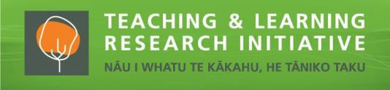

Jane Furness and Judy Hunter, Wilf Malcolm Institute of Educational Research, University of
Waikato; with Bronwyn Yates, Peter Isaacs and Katrina Taupo, Literacy Aotearoa Project dates: January 2017 – December 2018

Introduction

In this project we worked with tutors in Literacy Aotearoa adult literacy and numeracy (L+N) programmes. We drew on a Māori wellbeing assessment framework (Hei Ara Ako ki te Oranga) to facilitate its use in classroom practice and extend its application in multicultural settings in order to make visible the links between wellbeing and L+N learning for diverse learners. We trialed the use of social media as a relevant technology for learners enrolled in L+N programmes for the purposes of identifying and recording wellbeing outcomes.

Aims

The project aimed to capture the broader outcomes that are important to learners in their lives, beyond the L+N skills routinely assessed as part of adult L+N programmes. The goal was to build on a framework developed for Māori adult L+N learners but not in widespread use. Locating the framework conceptually within a personal, relational and collective model of wellbeing, we aimed to provide opportunity for tutors and diverse learners to recognise, value and enhance broad wellbeing outcomes. The project sought to achieve a meaningful and manageable process for using the framework within programmes. The research questions were:

- How can a wellbeing framework be further developed and incorporated into adult L+N programmes in ways that engage tutors and learners in broad wellbeing outcomes, and that are meaningful and manageable for them?
- What broad wellbeing outcomes can adult learners identify as a result of their engagement in L+N learning?
- How does the use of a wellbeing framework help learners assume ownership of their continuing learning?

Why is this research important?

The project helped fill the gap in knowledge about the broad range of outcomes of adult L+N programmes that enhance wellbeing, enabling a more complete picture of the value of L+N programmes to learners, families, communities and society. We have a clearer picture of how outcomes of L+N learning that are important to people in their lives can be captured in a meaningful and manageable way.

Key findings

A wellbeing framework can be embedded in L+N programmes in ways that engage tutors and learners meaningfully and manageably through tutors’ skill at bonding the group; tutor-instigated regular, collaborative, discussion-based mind-mapping on L+N learning linked to wellbeing outcomes; and overt and regular linking between their L+N learning and wellbeing outcomes as a natural part of classroom conversation.

Learners’ wellbeing outcomes identified as a result of their engagement in L+N learning included: accomplishment of new or enhanced L+N and other broad societal knowledge and skills; self-care; enhanced communication, whānau relationships and support of whānau; increased self-esteem, self-efficacy and sense of self-worth; belonging and whanaungatanga; autonomy and independence; and optimism and planning for the future. Benefits flowed on to family members.

Potential for privacy breaches and need for technology support inhibited the usability of social media for identifying and recording wellbeing outcomes.

Implications for practice

Broad wellbeing-related outcomes are important to L+N learners because they are connected to what matters to them in their lives. Together with skills outcomes, they provide a more complete picture of the benefits of their L+N learning.

Identifying and recording wellbeing outcomes from L+N learning can be supported by organisation-wide valuing of wellbeing outcomes, provision of time and space in programmes for paying attention to them, and opportunities to build knowledge of the concept and its manifestation in people’s lives.

Respectful and caring relationships founded on whanaungatanga, manaakitanga, trust, reciprocity and tutor belief in learner strengths provide the context for paying attention to and delivering wellbeing outcomes.

Valuing of wellbeing outcomes can be established from the outset through whakawhanaungatanga in which diverse learners identify, with their tutors, L+N learning goals that are connected to what is important to them in their lives.

Our partners

Our partner in this project was Literacy Aotearoa, the largest provider of Tertiary Education Commission-funded L+N education for adults. Its Poupou deliver L+N tuition to over 8,500 people nationally as individuals or in groups in workplaces, homes and communities. A Kaupapa Māori organisation, Literacy Aotearoa has an explicit commitment to Māori learners within a broader commitment to all learners. We partnered with Literacy Aotearoa at two levels: with their leaders and with tutors.
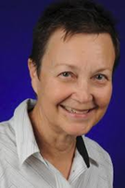
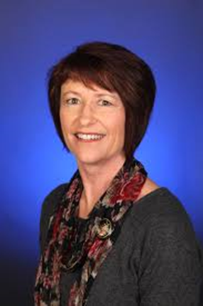
Jane Jane Judy Judy

Contact details Furness Hunter

Dr Jane Furness jane.furness@waikato.a.nz

Dr Judy Hunter judy.hunter@waikato.ac.nz

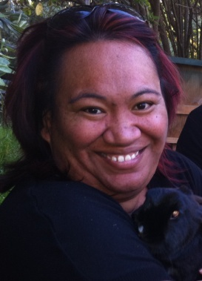
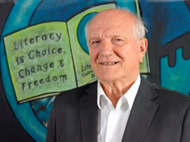
Research Partners

Hutchings, J., Yates, B., Isaacs, P., Whatman, J., & Bright, N. (2013). Hei Ara Ako ki te Oranga: A model for measuring wellbeing outcomes from literacy programmes. Wellington, New Zealand: NZCER. Bronwyn Yates Peter Isaacs Katrina Taupo

